BELG 4253810/07 SUPERBREEDER 810-A Star on the rising?
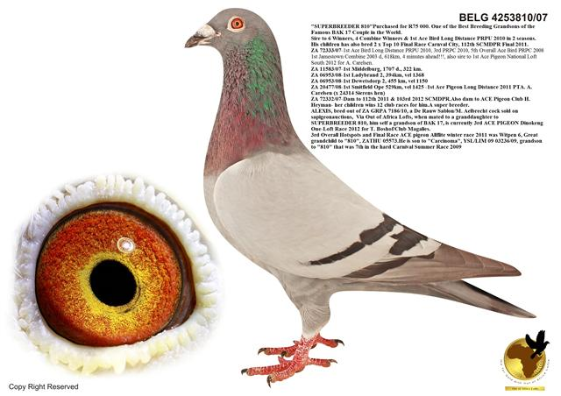
BELG 4253810/07
"SUPERBREEDER 810"
Purchased for R75 000. One of the Best Breeding Grandsons of the Famous BAK 17 Couple in the World.
Sire to 6 Winners, 4 Combine Winners & 1st Ace Bird Long Distance PRPU 2010 in 2 seasons.
His children and grandchildren are breeding winners and One-Loft Performers for various Fanciers all over South Africa
His children has also bred 2 x Top 10 Final Race Carnval City, 112th SCMDPR Final 2011.
ZA 72333/07-1st Ace Bird Long Distance PRPU 2010, 3rd PRPC 2010, 5th Overall Ace Bird PRPC 2008 1st Jamestown Combine 2003 d, 618km, 4 minutes ahead!!!, also sire to 1st Ace Pigeon National Loft South 2012 for A. Carelsen.
ZA 11583/07-1st Middelburg, 1707 d., 322 km.
ZA 06953/08-1st Ladybrand 2, 394km, vel 1368
ZA 06953/08-1st Dewetsdorp 2, 455 km, vel 1150
ZA 20477/08-1st Smitfield Ope 529km, vel 1425 -1st Ace Pigeon Long Distance 2011 PTA. A. Carelsen (x 24314 Sierens hen)
ZA 72332/07-Dam to 112th 2011 & 103rd 2012 SCMDPR.Also dam to ACE Pigeon Club H. Heyman- her children wins 12 club races for him.A super breeder.
ALEXIS, bred out of ZA GRPA 7186/10, a De Rauw Sablon/M. Aelbrecht cock sold on sapigeonauctions, Via Out of Africa Lofts, when mated to a granddaughter to SUPERBREEDER 810, him self a grandson of BAK 17, at one stage 3rd ACE PIGEON Dinokeng One-Loft Race 2012 for T. Boshof/Club Magalies.
His grandson ZA GRPA 00635/12 "SUNNY GIRL"
TOP RACER AT DINOKENG LOFTS
Raced under "PIGEON FRIENDS SYNDICATE"
32nd 3rd Super Turbo Race
16th Final Dinokeng One-Loft Race
14th Place Prize Winner of R14 000 Final Race Dinokeng
For Witpen Hokke-A. Reynders
3rd Overall Hotspots and Final Race ACE pigeon Allflite winter race 2011 was Witpen 6, Great grandchild to "810", ZATHU 05573.He is son to "Carcinoma", YSL/LIM 09 03236/09, grandson to "810" that was 7th in the hard Carnival Summer Race 2009 entered by the Cachalia brothers.
Marius Klingbiel
Purchased above described Witpen 6 on Carnival Auction, and Marius again entered his child in Carnival Summer Race 2012 that was 9th Final race, 2nd Ace Overall 2012, only 23 daybirds.
Andre Carelsen
ZA 72333/07-1st Ace Bird Long Distance PRPU 2010, 3rd PRPC 2010, 5th Overall Ace Bird PRPC 2008 1st Jamestown Combine 2003 d, 618km, 4 minutes ahead!!!, also sire to 1st Ace Pigeon National Loft South 2012 for A. Carelsen
Feedback from Hentu Heyman that has a direct daughter of SUPERBREEDER 810"
"QOUTE" -Hentu Heyman
Dis wat ek tot dusver gebroei het uit - ZA 72332 – 2007, direkte dogter van “810”.
Almal is direkte kinders van haar.
Park 004/2010 – 3 x 1st including federation win with 16 minutes and best bird on WCPTA truck(5250 birds) with 5 minutes 617km, 1184 velocity.
2 x 2nd beaten by brothers on trap, 3rd & 4th in one and a halve seasons. Withdrew her to breeding loft.
Park 005/2010 – 3 x 1st including federation win with 1597 velocity, 380km, 2 x 2nd, 2 x 3rd, 3 x 4th in 2 seasons, withdrew to breading loft.
Park 007/2010 – 2 x 1st, including federation win with 1117 velocity, 490km, 3 x 3rd & 1x 4th.
Boland 016/2010 – 1 x 1st, 1x 2nd & 3 x 3rd & 1 x 4th, winning 1 – 60 sale race on 1618 velocity.
Boland 0909/2010 – 2 x 2nd , beaten on trap by brothers, 4t & 5th , places.
WCPTA 3951/2011 – 3 x 1st, 4 x 2nd, 3 x 3rd, 2 x 4th, raced her 12 weeks, timed her 9 times.
BDU/D 0904/2010 – Sprinter Zone 3 - 16th Hotspot 2 collecting 1$ - 50$ pools, basketed only Sprinter Zone 3 for final SCMDPR 2011, scored 112th collecting 1$ - 100$ pools.
BDU/D 0903/2011 – Sprinter 4, flew 103rd SCMDPR final 2012.
ZA 37734 – Raced only 2 races, 1 x 1st & 1 x 4th, put to stock.
ZA 37737 – Raced only 4 races, 1 x 1st, 2nd & 5th, put to stock.
WCPTA 1812/2010 – never raced, stock.
BDU/D 0903/2010 – never raced, nest mate of Sprinter Zone 3, stocked.
Dit is wat haar kinders reeds vir my gedoen het, en ek het die jaar met die kinders gebroei en wag om te sien wat hulle gaan oplewer.
Die duiwe vlieg stadig, 1100 velocities en ook oor die 1600 velocities. Hulle verskies eintlik hitte, en my meeste wenne was op warm dae met head wind.
‘810” IS FAST BECOMING A TOP BREEDER OF ONE-LOFT ACES.

